**Name**

**Lab#6 Cryptography Part 2**

First we create two folders named as original and hidden. The original one contains the files that we want to hide as shown below

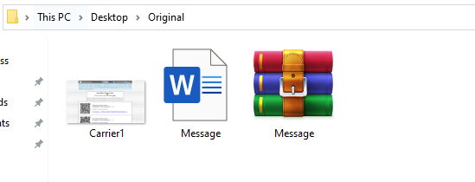

Then we create hidden folder that will reveal the message.docx file hidden in the image.

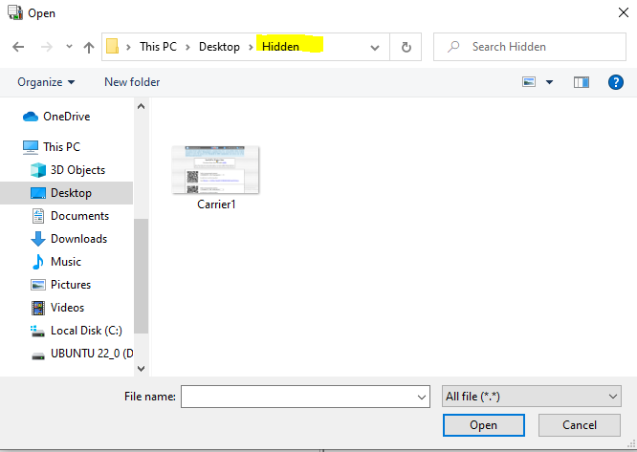

Now we click on hidden menu in open puff and hide the text file successfully

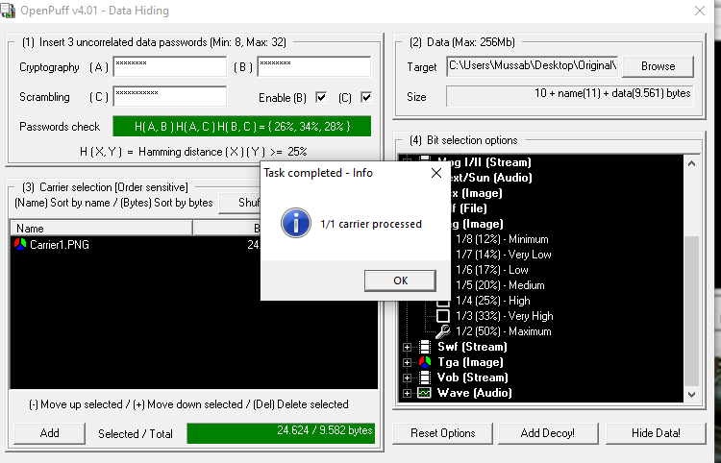

After that we open the file to see if anything is changed or not you can observe that there is no message file



Now we click on unhide menu to add the carrier file from the hidden folder

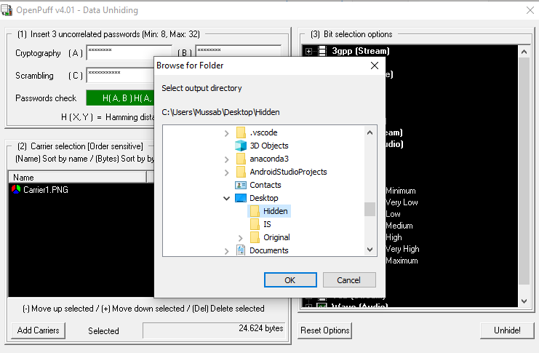

After that we click on unhide and select the same folder and document is shown that is hidden in the image

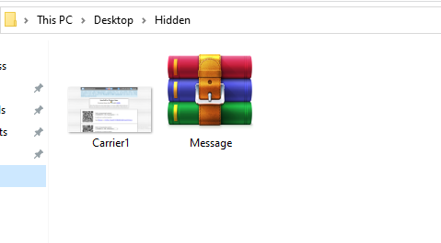

**Exercise 2**

**Step 1:**

First we create document country1.docx

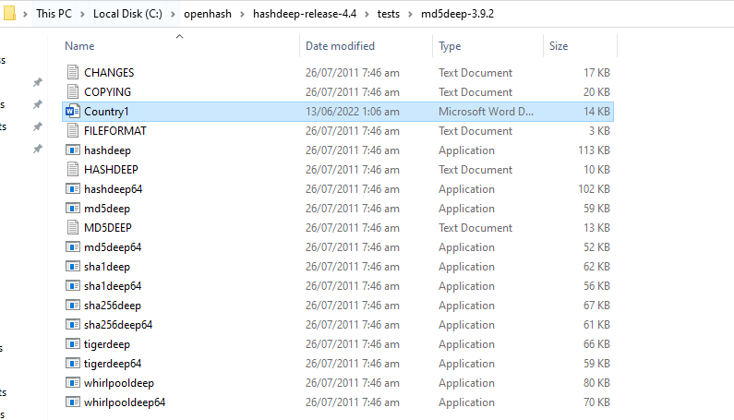

**Step 2:**

After that we run md5deep with this file to tell us hash value it has 128 bits

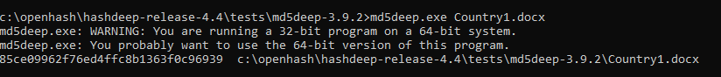

**Step 3:**

Then we run sample text MD5DEEP.TXT to see the difference in length. You will observe below the length is same only hash values are different because they use same md5 algorithm. It shows md5 is a strong hash generator with 128 bits so it is very hard to crack it



**Step 4:**

Now we create another document with same text but there is a catch we remove period to see the difference. As you can see only hash value is different otherwise length is same. This also shows how strong md5 is.

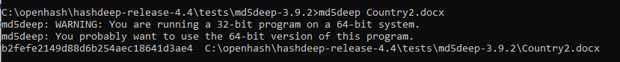

**Step 5:**

Now we have done the same things with sha1,sha256,whirlpool results are shown below



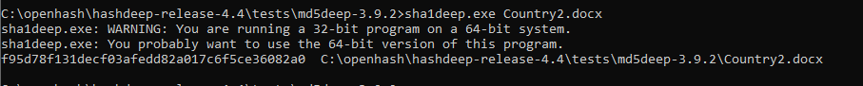

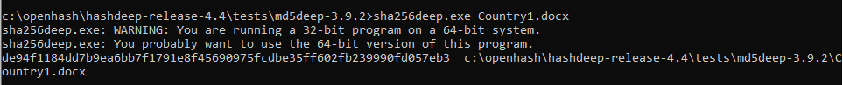



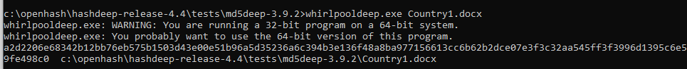

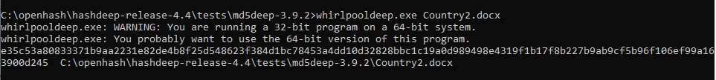

Length of all these hashes are Sha1 deep is 160 bit long for both documents. Sha256 is 256 bits for both documents. Whirlpool has 512 bits for both documents. We can see difference from their hash length more longer bits a hash algorithm has more stronger it is. So it will be more harder to crack it. With this discussion conclusion is that whirlpool is the strongest then sha256 the sha1. Weakest is md5.